Understanding Color Blindness Using Object-Oriented Programming Concepts

**Important information about this assignment:**

* **Due Date:** November 15th, 2023
* **Submission:** Please push your final submission to Github
* **Collaboration**: This programming assignment should be completed independently. You may discuss with your peers high-level concepts but all programming and research should be done completely on your own.

# Learning Objectives

1. Learn the different types of color blindness.
2. Implement the Object-Oriented concept: Class inheritance
3. Implement the Object-Oriented concept: Interfaces

# Overview

In this assignment, we delve into the world of color blindness, a condition that affects how individuals perceive and interact with the visual world. The core of this assignment revolves around creating statements explaining color blindness conditions using Java. Students will utilize Object-Oriented Programming concepts such as class inheritance and interfaces to model different types of color blindness accurately. The assignment is divided into several components, including class inheritances, base classes, and interfaces.

## Understanding Types of Color Blindness

To start, we encourage students to explore the diverse spectrum of color blindness types. It’s essential to have a comprehensive understanding of these conditions to effectively model them in code. You can find valuable resources with detailed information on different types of color blindness below but feel free to find resources on your own as well.

[Types of Color Vision Deficiency | National Eye Institute](https://www.nei.nih.gov/learn-about-eye-health/eye-conditions-and-diseases/color-blindness/types-color-vision-deficiency)

[Types of Color Blindness - All About Vision](https://www.allaboutvision.com/conditions/color-blindness/types-of-color-blindness/)

## The Impact of Technology

Color blindness can pose unique challenges when it comes to technology. Many aspects of our digital world rely on color cues, from user interface to data visualizations. Students should consider the difficulties that individuals with color blindness might encounter when using technology.

## Awareness

It’s crucial to consider how color blindness can impact daily life, including reading, interpreting data, and using technology. At the end of the assignment, you should reflect on questions like “How does color blindness affect people’s ability to code?” and “What is something that can be improved upon in Computer Science classes to make it easier for people with color blindness to learn?” to appreciate the real-world implications of their work.

As you embark on this assignment, you’ll not only gain valuable technical skills in Java but also develop a deeper awareness of the challenges faced by those with color vision deficiencies. By the end of this assignment, you will be well-equipped to model and understand the diverse world of color blindness and its impact on technology and everyday life.

# Setup

To begin on this project, please follow these steps:

1. Click on the Github Classroom Invitation link for this assignment:
2. Accept the invitation.

Once you have created your team and joined it, clone a local working copy of your repository as you have done in previous assignments. It is important to clone it somewhere outside of your previous clone repositories (e.g., ~/cs345/**title**) to avoid nesting local repositories. Your repository will contain some skeleton code to help you get started.

If you have any questions or issues during this process, please don’t hesitate to ask for assistance.

# Object-Oriented Concepts

## Class Inheritance

Class inheritance is a fundamental concept in Object-Oriented Programming. It allows a new class to reuse the code of an existing class. The new class is known as the subclass, and the existing class is called the base class. The subclass inherits all of the attributes and methods of the base class, but it can also have its own, unique attributes and methods as well. Inheriting the attributes and methods of the base class allows for the creation of hierarchical structure classes, with each class extending the functionality of the class before it.

Inheritance is also useful because it can make your code more reusable and it also reduces the amount of code duplication between two subclasses. There are two main types of inheritance in Object-Oriented Programming: single inheritance and multiple inheritance. In single inheritance, a subclass can only inherit from one base class. In multiple inheritance, a subclass inherits from multiple base classes. In this assignment, you should only worry about single inheritance.

In this assignment, we use class inheritance to create a hierarchy of color blindness types. This hierarchy allows us to model various forms of color blindness accurately, building upon a common foundation while customizing attributes and methods for each specific type.

### Why is Inheritance important for this assignment?

1. Code Reusability: By using class inheritance, we can reuse the code and attributes from a base class (**Disability**) for various types of disabilities, such as **ColorBlindness**. This avoids redundancy, making out code more efficient and easier to maintain.
2. Hierarchical Structure: Inheritance enables the creation of a hierarchical structure. Each color blindness type inherits characteristics from the base class and extends them to represent its unique features. This ensures a logical and structured representation of the different conditions.
3. Uniform Interface: Inheritance enforces a consistent interface for the color blindness types. The methods and attributes inherited from the base class maintain a common structure, making it easier for developers to work with and understand the various types.
4. Scalability: If we wanted to add more color blindness types or make modifications, inheritance simplifies the process. We can create new subclasses without altering the base class, which is critical for maintaining the integrity of the codebase.

At the end of this assignment, please answer these questions in **Questions.txt** and upload it to Github with the rest of your code.

1. What is the purpose of class inheritance in this assignment?
2. How does inheritance enhance code reusability and maintainability in the context of this assignment?
3. What are the advantages of maintaining a hierarchical structure of classes for the various color blindness types?

## Interfaces

Interfaces are a fundamental part of Object-Oriented Programming. In your assignment, you use interfaces to define a contract that specifies what methods must be implemented by classes that implement the interface. Specifically, you have **AssistiveTechnology, DigitalAccessibility,** and **EnvironmentalAssistance**.

### Why are Interfaces Important for This Assignment?

1. Forcing Method Implementation: Interfaces ensure that any class implementing them must provide specific methods. In this assignment, these methods define behaviors associated with recommendations for color blindness assistance, making sure that they are consistent across all classes.
2. Achieving Multiple Inheritance-like Behavior: Java supports multiple interfaces, allowing a class to implement more than one interface. In the context of your assignment, this is crucial because it enables classes to inherit and provide behaviors from multiple sources, without the complexity of multiple inheritance.
3. Polymorphism and Flexibility: Interfaces support polymorphism, allowing objects of different classes to be treated as objects of a common interface. This flexibility is vital when you want to work with diverse color blindness types in a uniform way.

At the end of this assignment, please answer the following questions in the provided **Questions.txt** and upload it to Github with the rest of your code.

1. What is the purpose of interfaces in this assignment?
2. How do interfaces enforce consistency in method implementation across different classes in your assignment?
3. Give an example of how interfaces enhance code modularity and maintainability in this assignment.

# Software Requirements

* **TODO 1.1**: Implement the AssistiveTechnology interface.
* **TODO 1.2**: Implement the DigitialAccessibility interface.
* **TODO 1.3**: Implement the EnvironmentalAssistance interface.
* **TODO 2.0**: Implement the constructor and methods in the Disability class.
* **TODO 3.0**: Implement the constructor in the ColorBlindness class.
* **TODO 3.1**: Implement the getImpactOnVision() method in the ColorBlindness class.
* **TODO 3.2**: Implement the getType() method in the ColorBlindness class.
* **TODO 4.0**: Give the definition of each type of color blindness in the ColorBlindness class.
* **TODO 4.1**: Explain how each type of color blindness affects someone's vision in the ColorBlindness class.
* **TODO 5.0**: Make it so AccessibilityRequirements implements the three interfaces
* **TODO 5.1**: Implement the recommendedAssistiveTechnologies() method in the AccessibilityRequirements class.
* **TODO 5.2**: Implement the digitalTools() method in the AccessibilityRequirements class.
* **TODO 5.3**: Implement the environmentalAssistance() method in the AccessibilityRequirements class.
* **TODO 6.0**: Implement Constructor in the Human class.
* **TODO 6.1**: Implement the getName() method in the Human class.
* **TODO 6.2**: Implement the getColorBlindnessType() method in the Human class.
* **TODO 6.3**: Implement the setColorBlindnessType() method in the Human class.
* **TODO 6.4**: Implement the generateNarrative() method in the Human class.
* **TODO 6.5**: Implement the setHobby() method in the Human class.
* **TODO 6.6**: Implement the setChallenge() method in the Human class.

# Sample Output

This output will not be about Color Blindness as it is your job to read and find the definitions, impacts on vision, and accessibility suggestions for each type of color blindness. Below is an example of how the output should be formatted and how in-depth you should be with each explanation.

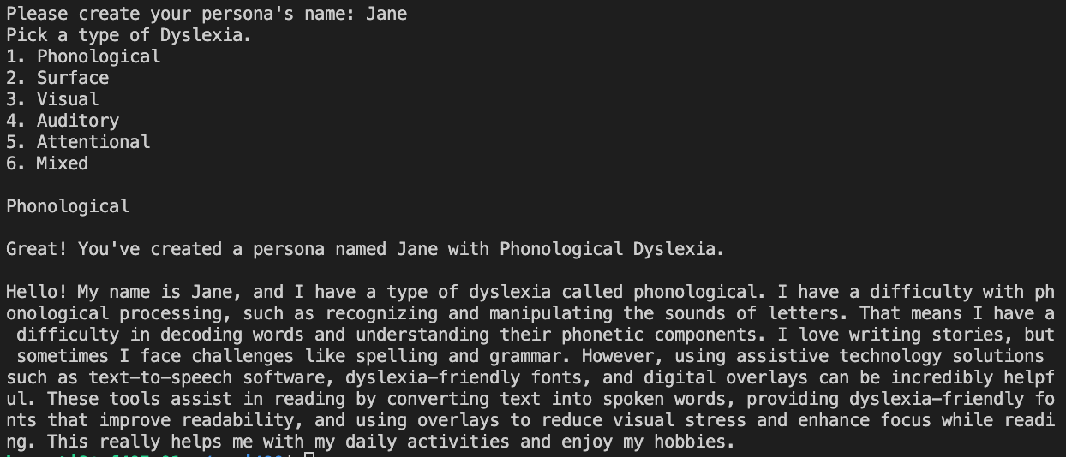

# Notes

Your grade will be partly based on the correctness of pairing the color-blindness with the medical name. **It is your responsibility to research and confirm the output.**